EE5355 DISCRETE TRANSFORMS AND APPLICATIONS

PROJECT JPEG-Baseline

NAME: PAVAI ARCHIMEDES

ST ID:1001233996

**OMEGA SERVER:**

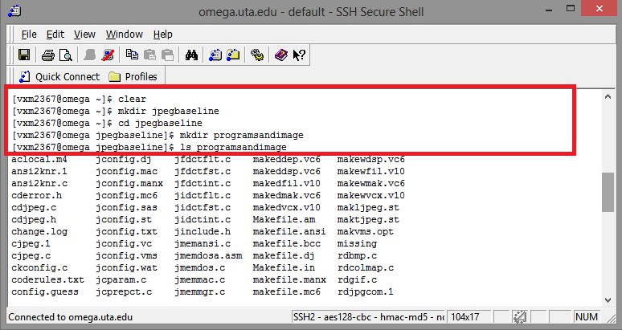

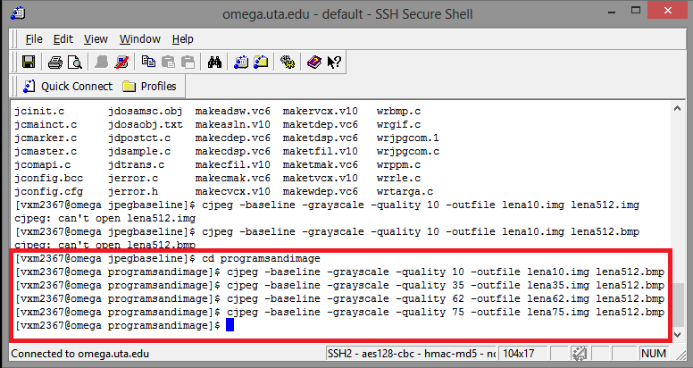

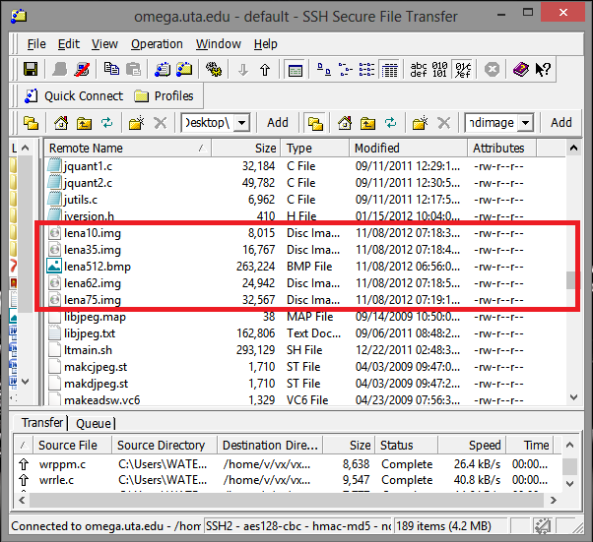

**MATLAB PROGRAM:**

clc;

close all;

clear all;

lena = imread('lena512.bmp');

imshow(uint8(lena));

title('ACTUAL IMAGE OF LENA');

figure;

lena10=imread('lena10.img');

subplot(2,2,1);

imshow('lena10.img');

title('RECONSTRUCTED IMAGE lena10.img FOR 0.25 BPP');

lena35=imread('lena35.img');

subplot(2,2,2);

imshow('lena35.img');

title('RECONSTRUCTED IMAGE lena35.img FOR 0.50 BPP');

lena62=imread('lena62.img');

subplot(2,2,3);

imshow('lena62.img');

title('RECONSTRUCTED IMAGE lena62.img FOR 0.75 BPP');

lena75=imread('lena75.img');

subplot(2,2,4);

imshow('lena75.img');

title('RECONSTRUCTED IMAGE lena75.img FOR 1 BPP');

lena = double(lena);

lena10 = double(lena10);

lena35 = double(lena35);

lena62 = double(lena62);

lena75 = double(lena75);

sum1=0;

sum2=0;

sum3=0;

sum4=0;

for i=1:512

for j=1:512

sum1 = sum1+(lena(i,j)-lena10(i,j))^2;

sum2 = sum2+(lena(i,j)-lena35(i,j))^2;

sum3 = sum3+(lena(i,j)-lena62(i,j))^2;

sum4 = sum4+(lena(i,j)-lena75(i,j))^2;

end

end

MSE_25 = sum1/(512*512);

MSE_50 = sum2/(512*512);

MSE_75 = sum3/(512*512);

MSE_100 = sum4/(512*512);

var_25 = var(var(lena10));

var_50 = var(var(lena35));

var_75 = var(var(lena62));

var_100 = var(var(lena75));

SNR_25 = 10*log10(var_25/MSE_25)

SNR_50 = 10*log10(var_50/MSE_50)

SNR_75 = 10*log10(var_75/MSE_75)

SNR_100 = 10*log10(var_100/MSE_100)

OUTPUT:

ACTUAL IMAGE:



RECONSTRUCTED IMAGE:



CONCLUSION:

|  |  |  |  |  |
| --- | --- | --- | --- | --- |
| **BIT RATE**  **(bits per pixel)** | **0.25** | **0.50** | **0.75** | **1.00** |
| **SNR**  **(dB)** | **41.4852** | **45.7990** | **47.6449** | **48.8614** |
|  |  |  |  |  |